# **Mechanical**

The mechanical sub-team follows the following process:

## Design

The design phase consists of reading through and understanding the CalPoly Cubesat standards that we are required to meet. Meeting these requirements is our primary priority to ensure compatibility with the launch pod. All members of the team are asked to read through the specifications laid out to eliminate possibilities of misunderstandings and to catch possible mistakes in the design. Our secondary priority is to ensure sub-team components securely fit inside our 3U design, and that the required interfaces are present.

We are currently in the design phase of the project. To date we have completed our first design iteration of the external skeletal structure. The structure and some of the sub-system components have been modelled with the use of NX. In Figure 1, you can see the bare structure of the 3U.

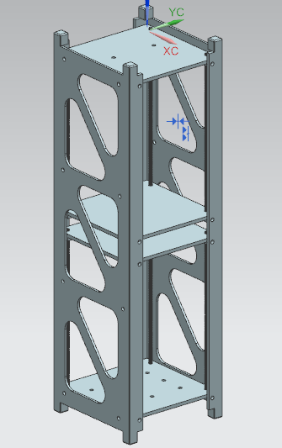

Figure 1- Skeletal structure of 3U cubesat

The 3U is sectioned into a Top Network and Bottom Network, to create a modular design. This enables the satellite to be worked on by multiple sub-systems, and makes for easy assembly.

|  |  |
| --- | --- |
| Figure 2- Top Network housing all the electrical boards | Figure 3- Bottom Network housing the Aurora spectrometer |

Another feature is the threaded rails found in both networks. This is especially useful in the Top Network as it allows us change the location of the board stack in the Z direction. Some of the sub-team components have also been designed and modelled by the team.

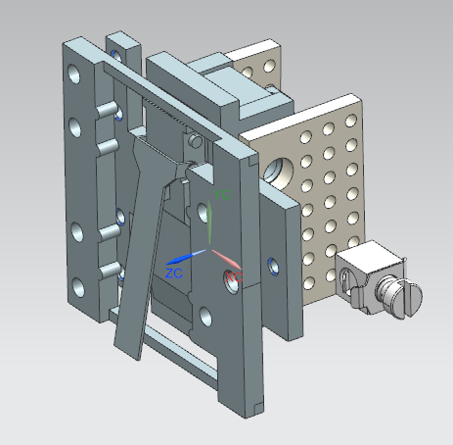

Figure 4- Antenna Deployer mechanism

The Antenna Deployer employs the use of Nylon thread to secure the antennas to the solar panels during launch. To deploy we use resistive Nichrome wire to cut through the Nylon thread, to release the antenna. The shape of the antenna forces it to spring into the deployed state.

|  |  |
| --- | --- |
|  |  |

Figure 5- Magnetorquer holders designed to secure the magnetorquers to the structure

Another sub-team components are the magentorquer holders designed to be simple interfaces to secure the magnetorquers to the structural plates.

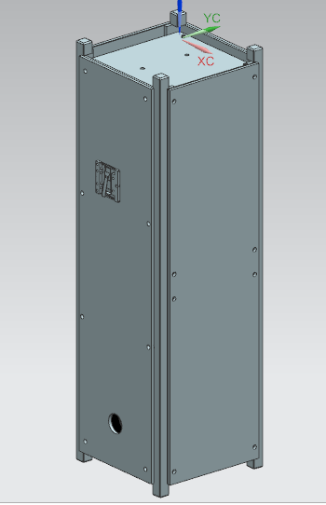

Figure 6- Fully assembled structure to date

Our future work consists of modelling remaining components such as deployment switches, a remove before flight pin, magnetorquers, antennas, accurate solar panels, and possibly a secondary payload, FIPEX. Once these tasks are completed we will have Adam McLean, the Bergeron Machinist, review the design to see if certain aspects can be improved from a structural and machining standpoint.

## Prototype and Simulation

As the design comes closer to completion we would like to prototype the CAD model using 3D printers available in the Design Commons. This will allow us to get a better idea of fits and allow us to test the interfaces and mechanisms. We have started to prototype some of the smaller pieces as seen below,

|  |  |
| --- | --- |
|  |  |

Figure 7- Horizontal magnetorquer holders printed for a fit check

In addition, we will also perform structural and thermal simulations to better understand the loads faced by our satellite during launch and orbit. To begin we will perform a part-by-part modal analysis, and random vibration simulations as outlined by CalPoly specs. Next we will perform an orbital heating simulation for a small range of possible orbits.

In this stage, we expect to run into problems which may force us to redesign parts of the 3U. We will again perform the same procedures on the redesigned components.

## Manufacture

At this stage the 3U structure will be sent out to be machined by professional machinists, to ensure high level tolerances are met. In parallel, we will manufacture some of the internal components, such as the antenna deployer mechanism, as those have moderate tolerances that we can meet.

## Test

Once the structure components are machined we will assemble the skeletal structure and perform vibration testing using the Shaker Table, in the CRESS lab and the CubeSat Vib Fixture manufactured earlier this year.

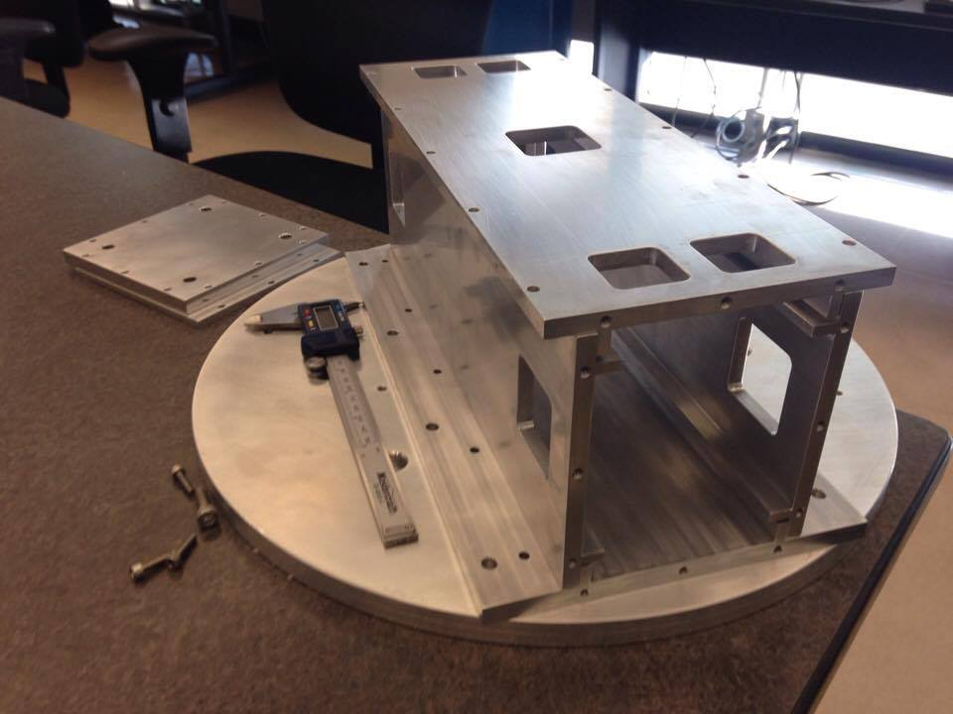

Figure 8- Vib fixture for 3U cubesats

We will also perform TVAC tests on internal components such as the ACS board, to verify compliance requirements. Once all tests are complete we aim to write a thorough report discussing our results and findings.

## Components List

Table 1- List of components for the mechanical team

|  |  |  |
| --- | --- | --- |
| **Component** | **Sub Components/ Versions** | **Quantity** |
| Side Rail | Side Rail Left | 1 |
| Side Rail Right | 1 |
| Main Link | Main Link 1 | 1 |
| Main Link 2 | 1 |
| Main Link 3 | 1 |
| Main Link 4 | 1 |
| Solar Panels | Solar Panel Backing | 2 |
| Solar Panel 1.1 | 1 |
| Solar Panel 1.2 | 1 |
| Solar Panel 2 | 2 |
| Rods | / | 8 |
| Antenna Deployer | Outer Holder | 2 |
| Switch Holder | 2 |
| Nichrome Wire | 2 |
| Nylon Wire | 4 |
| Limit Switch | 2 |
| Terminal Blocks | 4 |
| PCB | 4 |
| Magnetorquer Holders | Horizontal Clamp | 2 |
| Horizontal Thru | 2 |
| Vertical Clamp | 1 |
| Vertical Thru | 1 |